Project Report on

**AUTOMATIC SEGREGATION OF WASTE MATERIALS**

*Submission to THE ROBOTICS CLUB - SNIST as a part of INDUCTION'23*

TEAM NO - 07

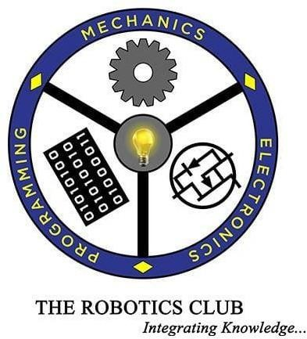

THE ROBOTICS CLUB-SNIST

SREENIDHI INSTITUTE OF SCIENCE AND TECHNOLOGY

(AUTONOMOUS)

(Affiliated to JNTU University, Hyderabad) Yamnampet, Ghatkesar, Hyderabad – 501301.

2023

**CERTIFICATE**

This is the project work titled ‘**Upakshya Viraha**’ by ‘**M Manikanth Reddy, Asiniparthi Livruth, K. Vivek Reddy, Srinath Itham, Barla Sai Anjanna Reddy, Sravya Chavali, P. Phani Anirudh, Yahswika, Ritika Anshu Reddy Vemalla**’ under the mentorship of ‘**Sunku Giridhar Shanmukh** and **Kovidh Addhish G**’ and is a record of the project work carried out by them during the year 2022-2023 as part of INDUCTION under the guidance and supervision of

**Mr. D P Naga Ajay Kumar &**

**Ms. P Tapaswini Technical Heads**

**Mr. T Bharat Kumar The President of**

**THE ROBOTICS CLUB**

**Dr. A. PURUSHOTHAM**

**Faculty Advisor Mechanical Department**

**DECLARATION**

The project work reported in the present thesis titled **“Upakshya Viraha”** is a record of work done by Team 07 in **THE ROBOTICS CLUB** as a part of **INDUCTION-2023.**

**No part of the thesis is copied from books/ journals/ Internet and wherever the portion is taken, the same has been duly referred in the text. The report is based on the project work done entirely by TEAM (team number) and not copied from any other source.**

ACKNOWLEDGMENT

# This project report is the outcome of the efforts of many people who have driven our passion to explore into implementation of **Upakshya Viraha.** We have received great guidance, encouragement and support from them and have learned a lot because of their willingness to share their knowledge and experience.

We thank our technical heads **Mr. D P Naga Ajay Kumar and Ms. P Tapaswini** for being with us till the end of the project completion.

We thank all the members of the **Steering Body**, **Executive Body, Technical Advisory Board, and Club's Incubation and Competence Committee** of **The Robotics Club** for helping us with crucial parts of the project. We are deeply indebted to **Mr. T Bharat Kumar -** The President, **Mr. N Abinav**

**-** The Vice President, **Mr. Jayanth Siva Madhav** - SAB Chairman and **Mr. S.V. Reddy** - General Secretary **THE ROBOTICS CLUB-SNIST** respectively and also every other person who spared their valuable time without any hesitation whenever we wanted.

We also thank our faculty advisor **Dr. A. Purushotham**, Professor Mechanical Department, who encouraged us during this project by rendering his help when needed.

Contents Pg. No

|  |  |  |
| --- | --- | --- |
| Chapter1 | Introduction: |  |
| 1.1 | Problem Statement |  |
| 1.2 | Introduction of the project |  |
| 1.3 | Literature survey |  |

|  |  |  |
| --- | --- | --- |
| Chapter2 | Architecture: |  |
| 2.1 | List of Figures |  |
| 2.2 | Components used |  |
| 2.3 | Hardware |  |
| 2.4 | Software |  |

|  |  |  |
| --- | --- | --- |
| Chapter3 | Implementation and working: |  |
| 3.1 | Block diagram |  |
| 3.2 | Circuit diagram |  |
| 3.3 | Working |  |
| 3.4 | Flowchart |  |

|  |  |  |
| --- | --- | --- |
| Chapter4 | Experimental Results and Conclusions: |  |
| 4.1 | Results |  |
| 4.2 | Future enhancements |  |
| 4.3 | Conclusions |  |
| 4.4 | References |  |
| 4.5 | Source code |  |
| 4.6 | List of expenses |  |

ABSTRACT

“UPAKSHAYA VIRAHA”

Automatic Waste Segregation System

THE PROBLEM:

The nation and world is facing a huge problem today of disposal, segregation and recycling of solid waste, and improper management of these wastes are hazardous and dangerous to human health and ecological system. There is a rapid increase in capacity and categories of solid waste as a result of urbanization, constant economic growth, and industrialization. Global Waste Management Market reported that the amount of waste generated worldwide produced is 2.02 billion tones. “Wastes are not always waste if it is segregated as it was”. To properly manage the waste it has to be handled, segregated, transported and disposed so as to reduce the risks to the public lives and sustainable environmental. The economic value of waste is best comprehended when it is segregated. Currently there is no such system employed of segregation of glass, plastic and metallic wastes at industrial level.

THE TEAMS APPROACH TO THE PROBLEM: -

This paper proposes an automation of waste material segregation in scrap industry. This method is easy and simple solution of segregation of three types of wastes glass, metal and plastic. It is designed to sort the trash into metallic waste, plastic waste and glass waste ready to be processed separately for the next process of operation. The method uses inductive sensors metallic items, and capacitive sensors to distinguish between and dry waste. Experimental results show that the segregation of waste into metallic, plastic and glass waste has been successfully implemented using the automation of material segregation (AMS) method.

BLOCK DIAGRAM:

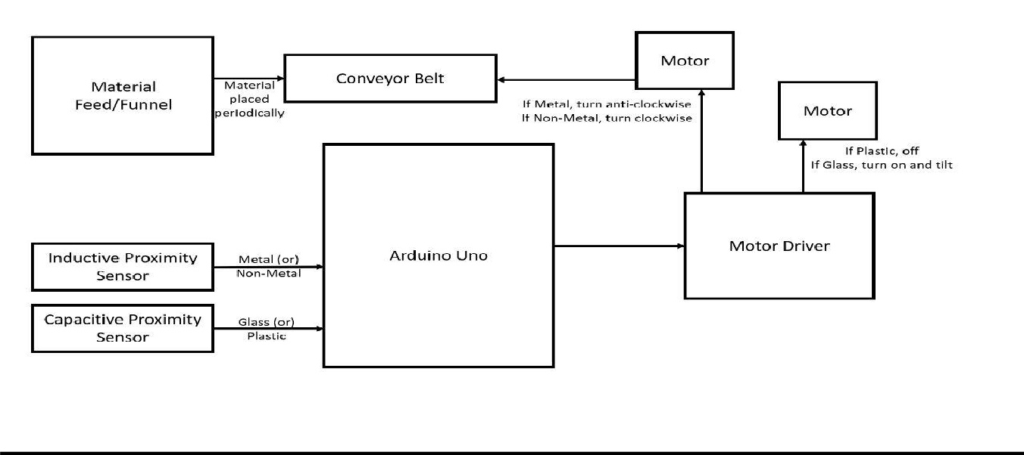

TITLE OF THE PROJECT: - Automatic Segregation of Waste Materials What do you feel is the most innovative part of the problem?

# Previously, waste segregation has been a manual and labor-intensive process, requiring individuals to sort the waste and separate it into different categories. Innovative waste segregation systems may incorporate sensor technologies, to detect and analyze the composition of waste. These sensors can provide additional information beyond visual capture, enabling more accurate identification and sorting. The Sensor technology can be used to detect the type of material and it’s chemical composition and perform the further following steps or process.

Automatic Conveyor Belts can be used to segregate the waste material put onto it, and help the waste to travel and reach the appropriate place, where it has to be dumped, after the sensing process for further tasks which can be performed. These robotic systems can be used to handle large quantities of waste efficiently and with the correct precision. These achievements are very important and useful in waste management for a happy, healthy and clean environment, sustain good surroundings and also for a pollution-free nature, keeping in view of the coming future.

IEEE FORMAT

Automatic Segregation of Waste Materials

1M.Manikanth Reddy, 2Asiniparthi Livruth, 3K.Vivek Reddy,4Srinath Itham, 5Barla Sai Anjanna Reddy,

6Sravya Chavali, 7P.Phani Anirudh, 8Yashwika, 9Ritika Anshu Reddy Vemalla

1,2,3,4,5,6,7,8,9The Robotics Club

*Sreenidhi Institute of Science and Technology*

Hyderabad, Telangana, India [mudusumanikanthreddy@gmail.com](mailto:mudusumanikanthreddy@gmail.com)[1], [alivruth@gmail.com](mailto:alivruth@gmail.com)[2], [kallam.vivekreddi23@gmail.com](mailto:kallam.vivekreddi23@gmail.com)[3],

[srinathitham2020@gmail.com](mailto:srinathitham2020@gmail.com)[4], [saianjanna261@gmail.com](mailto:saianjanna261@gmail.com)[5], [sravyachavali03@gmail.com](mailto:sravyachavali03@gmail.com)[6], [phanianirudhp14@gmail.com](mailto:phanianirudhp14@gmail.com)[7], [yashwikareddy08@gmail.com](mailto:yashwikareddy08@gmail.com)[8], [ritikaanshureddy@gmail.com](mailto:ritikaanshureddy@gmail.com)[9]

***Abstract*—Around the globe, solid waste generation is increas- ing day by day and the improper management of this waste is hazardous to human health and the ecological system. The world faces a problem of disposal, segregation and recycling of solid waste. The increasing population, urbanisation and industrialisation resulted in an increase in the generation of solid waste. Wastes are not always waste if they are segregated, transported and disposed of. The economic value of waste is best comprehended when it is segregated. Waste segregation will lead to the reduction of risks to public lives and a sustainable environment. Currently, there is no such system employed of the segregation of glass, plastic and metallic wastes at the industrial level. To segregate the waste material, the team propounds an automatic segregating bot consisting of sensors, conveyor belts, shaft motors, servo motors, motor drivers and microcontrollers. The inductive and capacitive sensors identify the type of material and the different materials are dumped into separate bins respectively, through the conveyor belt, the whole process is controlled by the microcontroller.**

***Index Terms*—Automation, segregation, solid waste, waste management.**

1. Introduction

The primary motive of this project is to aid the proper management of waste material in the scrap industry. The waste generation around the world was estimated to generate 2.24 billion tonnes of solid waste, amounting to 0.79 kilograms per person per day and it is expected to increase by 73 percent from 2020 levels to 3.88 billion tonnes in 2050. So it is necessary to manage the waste through recycling of solid waste. For this the segregation of waste is needed to be done, this paper proposes an automation of waste material segregation in the scrap industry. This gives the solution of segregation of three types of waste: glass, plastic and metal. It is designed to sort the trash into metallic waste, plastic waste and glass waste ready to be processed separately for the next p/2r/o2 cess. Automatic waste segregation will lessen the human interaction with waste materials and it reduces the threat through proper management of solid waste.

1. Literature Survey

Waste segregation can be defined as the process of iden- tifying, classifying, dividing and sorting garbage and waste products in an effort to reduce, reuse and recycle materials. In order to segregate waste appropriately, it is important to

correctly identify the type of waste that is generated. For the purposes of waste segregation at source, waste is identified and classified into the following categories depending on its biological, physical and chemical properties: Dry Waste, Wet Waste, Sanitary Waste, Hazardous Household Waste, etc. When waste is unsegregated, it may get contaminated with different types of waste being stored together. Waste Segregation is always stepped one for all types of waste management solutions that may be implemented either on an individual level or community level.

1. System Architecture
2. *Existing System*

The separation of waste has been assisted by many robots, including Dr. A. Prashant Gupta and Brintha Therese, who proposed using Raspberry Pi to create a Robotic Arm with Real-Time Image Processing, which can either be automated or can be operated manually. Jash Shah and Sagar Kamat presented an artificial intelligence-based system for identi- fying, removing, and sorting items on a moving conveyor. The majority of the top-performing object detection networks today use CNN (convolutional neural networks). Recycling and organic materials must be categorised using advanced ap- proaches since they are challenging to categorize. A worldwide strategy is required for industrial applications in addition to the gathering of datasets. The study proposes an optimal waste categorization method that is more accurate and efficient.

1. *Proposed System*

Waste plays a significant role in our society. Separating it into its own categories helps in effective recycling. For the process of separation, automatic segregation of waste bots is employed. It comprises sensors, a microcontroller, four motors and a motor driver to control them.

When the waste is dumped into the funnel, a single object is allowed fall on the conveyor belt. Firstly the object passes through the inductive proximity sensor. If the sensor detects a frequency which matches a metallic one the conveyor belt rotates in the opposite direction and falls in the respective bin else the belt moves forward and stops at the Capacitive proximity sensor. This sensor detects whether it’s plastic or glass. If it is plastic, with the help of rack and pinion the

* 1. *Inductive proximity sensor:* An inductive proximity sen- sor is a sensing device that detects metal targets using elec- tromagnetic energy and without contact.

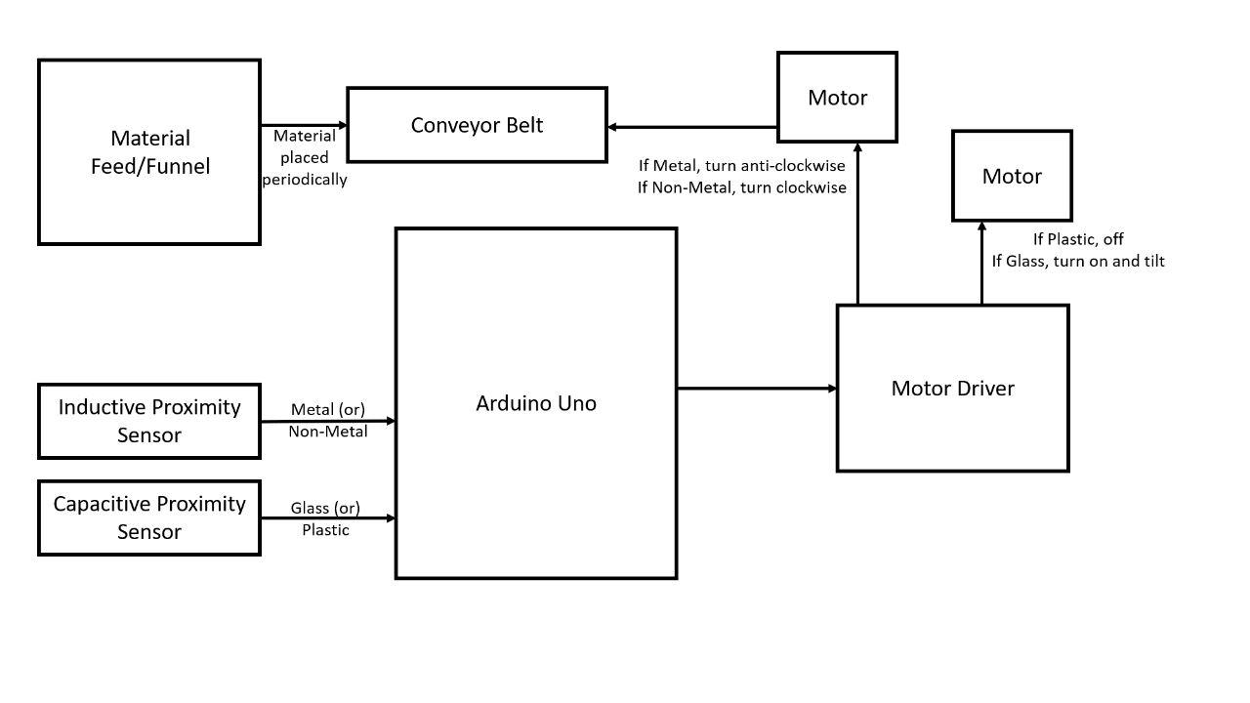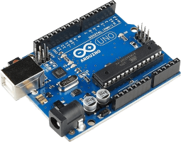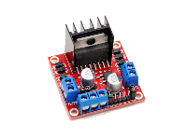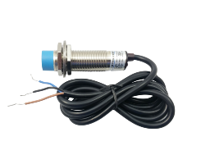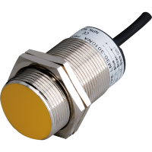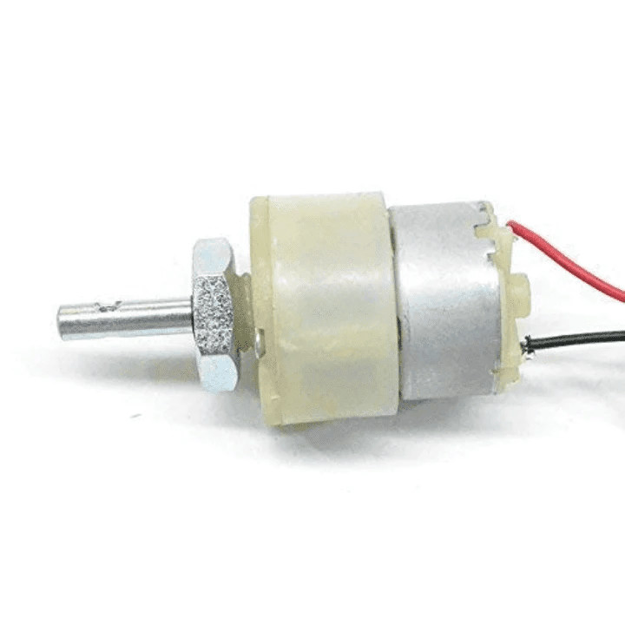

The sensing range of an inductive proximity sensor changes based on the type of metal being detected. They detect objects

Fig. 1. Workflow

object will be pushed in the opposite direction which then falls into the bin else the belt will be moved forward till the object is made to fall into the glass bin.

1. Architecture
2. *Hardware*
   1. *Arduino Uno:* The Arduino Uno is a microcontroller board based on the ATmega328 (datasheet). It has 14 digital input/output pins (of which 6 can be used as PWM outputs), 6 analog inputs, a 16 MHz crystal oscillator, a USB connection, a power jack, an ICSP header, and a reset button

Fig. 4. Inductive proximity sensor

and typically give a 0–10 VDC output based on the distance between the target and the sensor. Inductive proximity sensors enable the detection, without contact, of metal objects at distances of up to 60 mm.

* 1. *Capacitive proximity sensor:* Capacitive Proximity Sen-

sors can detect non-metal objects, such as liquids, plastics, and glass. They detect their targets through changes in capacitance

Fig. 2. Arduino Uno ATmega328P

The ATmega328 has 32 KB of flash memory for storing code (of which 0,5 KB is used for the bootloader). It also has 2 KB of SRAM and 1 KB of EEPROM.

* 1. *Motor driver L298N:* This L298N Motor Driver Module is a high-power motor driver module for driving DC and Stepper Motors. This module consists of an L298 motor driver

Fig. 5. Capacitive proximity sensor

between the sensor and target material. They usually have a larger sensing distance than their inductive counterparts, and it typically falls between 5 and 40 millimetres

* 1. *Center shaft motor:* These motors are simple DC Mo-

tors featuring gears for the shaft for obtaining the optimal performance characteristics. Nut and threads on shaft to easily connect and internal threaded shaft for easily connecting it to the wheel.

/2/2

Fig. 3. Motor Driver L298N

IC, a 78M05 5V regulator, resistors, a capacitor, Power LED, 5V jumper. L298N Module can control up to 4 or 2 DC motors with directional and speed control.

Fig. 6. Center shaft motor

They are known as Center Shaft DC Geared Motors be- cause their shaft extends through the centre of their gearbox

assembly. These standard-size DC Motors are very easy to use.

* 1. *Side shaft motor:* A side shaft motor has a high perfor- mance. Many can be made to run in the opposite direction

1. *Vector board:* A vector board is a solderable board used to prototype electrical circuits. All boards have provisions for I/O connectors. Components on this board can be soldered

Fig. 7. Side Shaft Motor

by switching leads where they attach to the motor. DC geared motor with metal gearbox used for high torque application and other automation purposes.

* 1. *Servo motor:* A servo motor is a self-contained electrical device that moves parts of a machine with high efficiency and great precision. In simpler terms, a servo motor is a BLDC motor with a sensor for positional feedback. This allows the output shaft to be moved to a particular angle, position, and velocity that a regular motor cannot do.

Fig. 10. Vector board

together to provide electrical connections to make up multiple circuits.

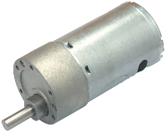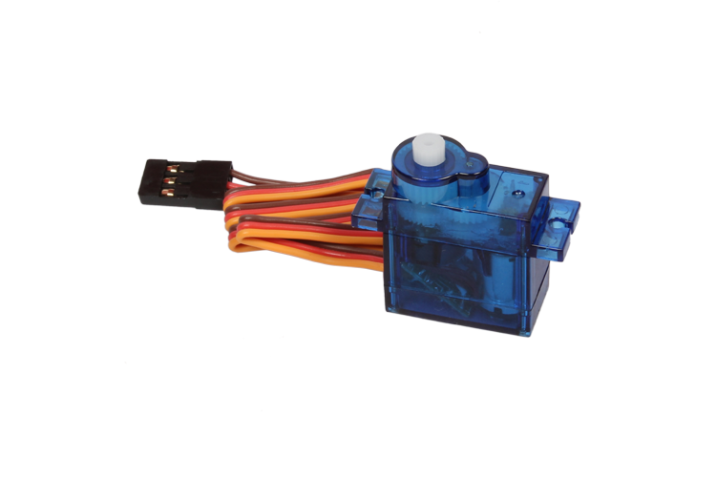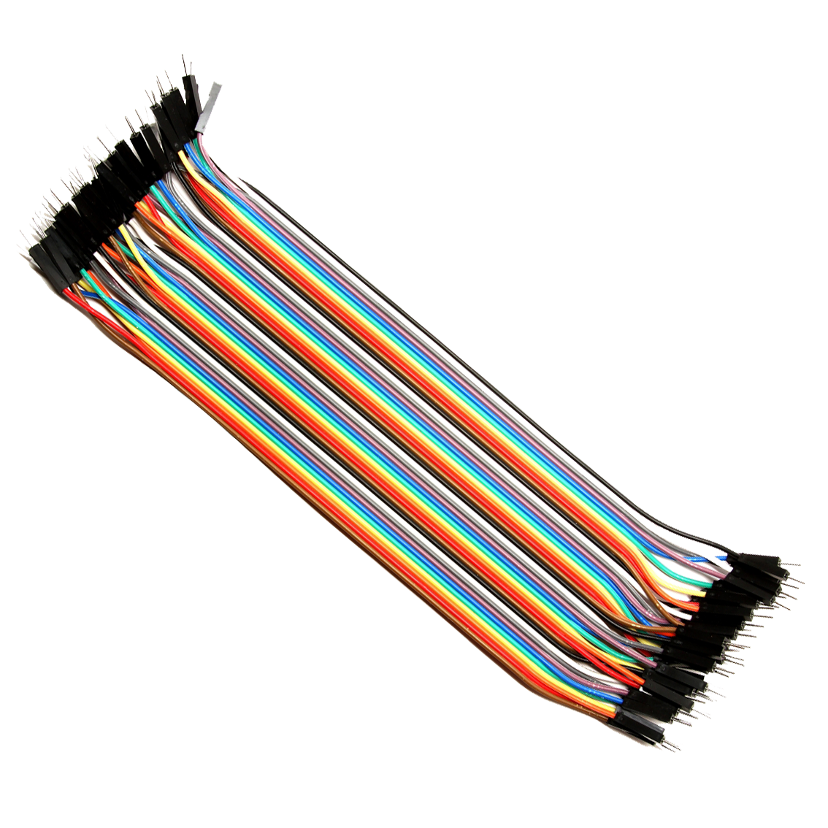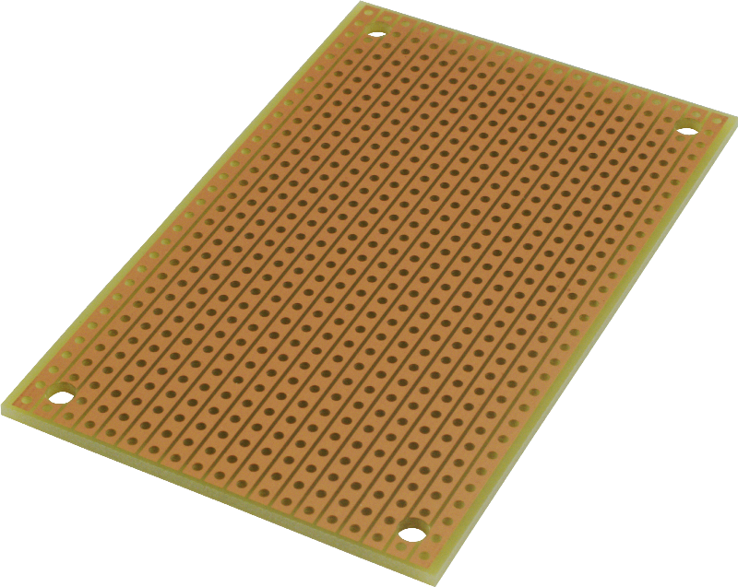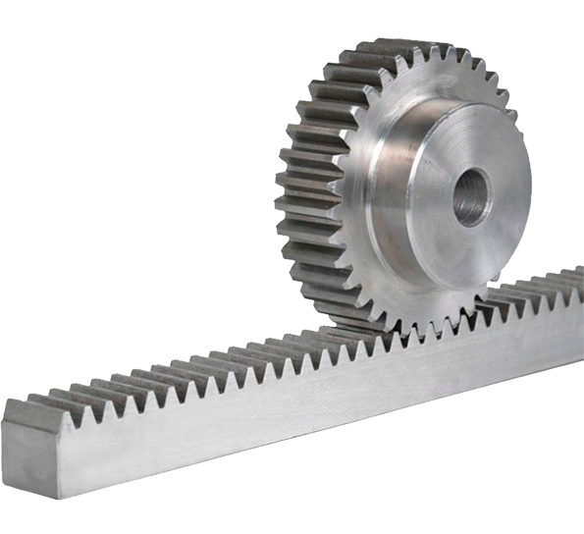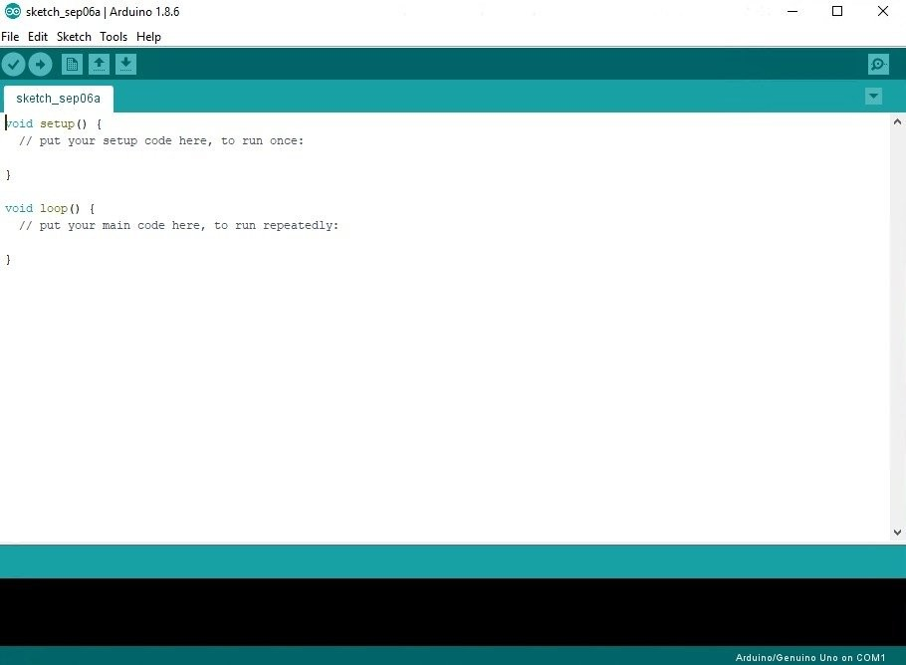

1. *Rack and Pinion:* Racks and pinions are power- transmission components primarily used for converting rotary to linear motion and vice versa.

Fig. 8. Servo Motor SG90

A servo motor is controlled by controlling its position using Pulse Width Modulation Technique. The width of the pulse applied to the motor is varied and sent for a fixed amount of time. Servo Motor generally requires a DC supply of 4.8 V to 6 V.

* 1. *Jumper wires:* Jumper wires are tiny metal connectors used to close or open a circuit part. They have two or more connection points, which regulate an electrical circuit board. Their function is to configure the settings for computer

Fig. 11. Rack and Pinion

Rack and pinion combinations are often used as part of a simple linear actuator, where the rotation of a shaft powered by hand or by a motor is converted to linear motion.

1. *Software*
   1. *Arduino IDE:* Arduino Integrated Development Envi- ronment is an open-source application software created by Arduino.

/2/2

Fig. 9. Jumper Wires

peripherals, like the motherboard. Jumper wires come in three versions: Male-to-male jumper, Male-to-female jumper, and Female-to-female jumper.

Fig. 12. Arduino IDE

The microcontrollers can be programmed using the C and C++ programming languages, using a standard API which is also known as the Arduino Programming Language. The

boards are equipped with sets of digital and analog in- put/output (I/O) pins that may be interfaced with various expansion boards.

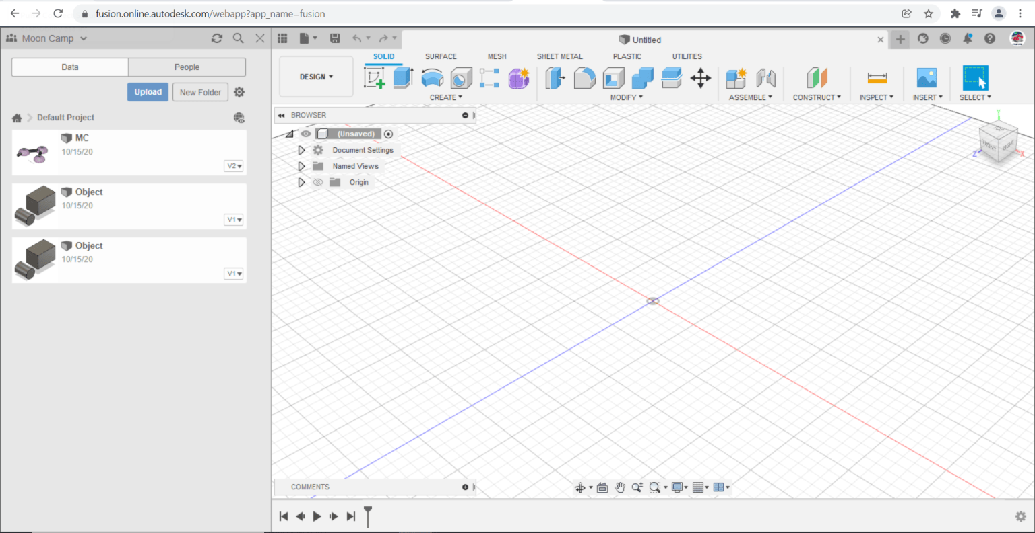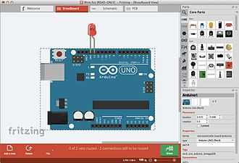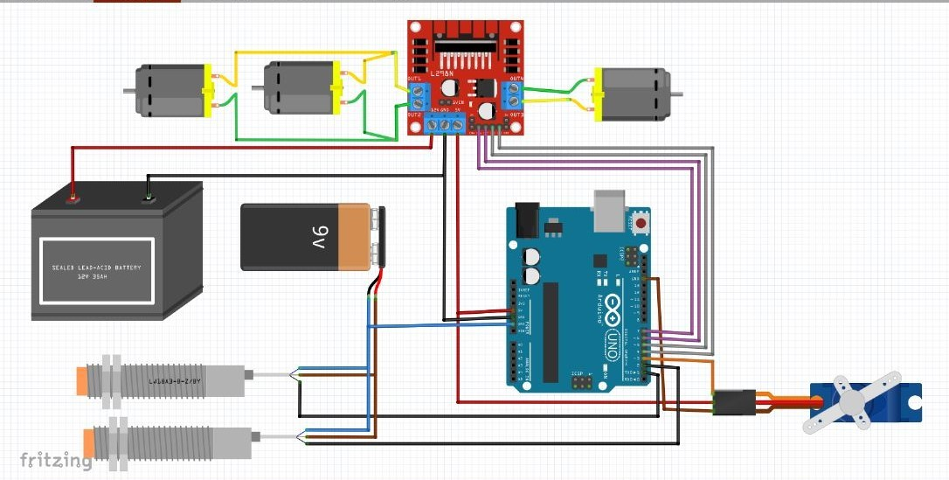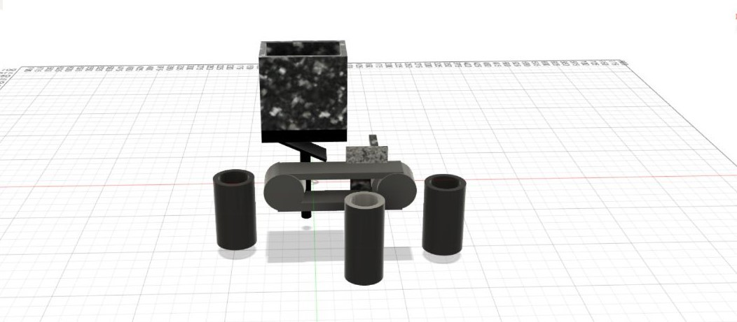

* 1. *Fusion 360:* Fusion 360 has built-in capabilities to do 3D modelling, sheet metal, simulation and documentation. It can manage manufacturing processes such as machining,

Fig. 15. Circuit diagram

Fig. 13. Fusion 360

milling, turning and additive manufacturing. It also has elec- tronic design automation (EDA) features, such as schema design, PCB design and component management. You can use it also for rendering, animation, generative design and a number of advanced simulation tasks (FEA).

* 1. *Fritzing:* This software allows a designer, artist, re- searcher, or hobbyist to document their Arduino-based pro- totype and create a PCB layout for manufacturing using the Processing programming language and the Arduino microcon- troller.

the Arduino Uno which commands the motor driver L298N accordingly, if the result is positive the belt is run in an anticlockwise direction by the side shaft motor which is instructed by the L298N and the material is dumped in the bin placed at the back of the belt. If the result is negative the material is moved forward to be examined by the Capacitive Proximity Sensor and again the result is sent to microcontroller Arduino, Motor Driver L298N gets commanded for each result respectively. If the material is plastic, then the motor driver runs the central shaft motor first with rack and pinion arrangement and the plastic is pushed into the bin in front. If it is a glass material then Conveyor Belt runs forward and dumps it into the bin at the end. All the connections 0f components of the product are shown in Fig. 15.

Fig. 14. Fritzing

This website allows users to exchange drafts and experi- ences, reduce manufacturing costs, and share experiences.

1. Working Mechanism

The working mechanism of the product is mostly controlled by the microcontroller Arduino Uno.

It begins after the user manually dumps the waste materi- als(metal,/2/g2lass and plastics) in the funnel. The Servo Motor SG90 which is directly controlled by Arduino Uno opens and closes the funnel making the materials slide onto the Conveyor Belt one after the other.

In segregating process Inductive Proximity Sensor, Capaci- tive Proximity Sensor, Motor Driver L298N are linked to the Arduino Uno as shown in Fig. 1.

The material on the Conveyor Belt is first examined by the Inductive Proximity Sensor and the result is sent to

Fig. 16. CAD Design of Prototype

1. Algorithm
   * 1. *ALGORITHM FOR PRODUCT FUNCTIONING*

* The waste materials are dumped into the funnel.
* Servo Motor SG90 opens and closes the funnel.
* Inductive proximity sensor examines the material slid onto the conveyor belt and the result is sent to the Arduino Uno ATmega328P.
* Arduino Uno gives commands to Motor driver L298N according to respective results.
* Result is positive then by the command from Arduino motor driver L298N instructs Side Shaft Motor to turn anti-clockwise making the Conveyor Belt to dump metal into Bin 1.
* If negative, the Conveyor Belt carries material to the range of the Capacitive Proximity Sensor to be examined and the result is sent to the microcontroller.
  + If the material is plastic, commanded by the microcon- troller motor driver instructs Central Shaft Motor such that the plastic is pushed into Bin 2 by rack and pinion setup.
  + If the material is glass, the motor driver instructs the Side Shaft Motor making a belt to carry the glass material to be dumped into Bin 3.
  + The bins are emptied once in a while after they are filled.

1. Future Enhancements

The model built by our team is an elementary prototype. It can be improved upon for higher degree of garbage segregation and disposal purposes.

Based on its functionality, the robot can be altered to detect and sort liquid and dry waste, biodegradable and non- biodegradable waste, as well as hazardous and radioactive material. It can be used in factories, industries, public places such as parks, gardens, malls etc to sort garbage efficiently for a cleaner, greener planet.

1. Conclusion

To conclude, the human effort of segregation will be reduced with the help of our robot. Thereby increasing hygiene in society and keeping the environment clean. The advantage is making a smart city through its work. Waste management is one of the most important challenges that a city faces

The discarded waste can then be processed to recover materials productively and metamorphose them into energy as usable fuels. This can be further developed with the help of machine learning and artificial intelligence to make a humanoid waste segregation robot.

References

1. Osoinach, Bryce. ”Proximity capacitive sensor technology for touch sensing applications.” Freescale White Paper 12 (2007): 1-12.
2. Sudha, S., et al. ”An automatic classification method for the environ- ment: Friendly waste segregation using deep learning.” 2016 IEEE Tech- nological Innovations in ICT for Agriculture and Rural Development (TIAR). IEEE, 2016.
3. Susanth GS, Livingston LJ, Livingston LA. Garbage waste segregation using deep learning techniques. InIOP Conference Series: Materials Science and Engineering 2021 (Vol. 1012, No. 1, p. 012040). IOP Publishing.
4. Nandhini, S., et al. ”Electronically assisted automatic waste segrega- tion.” 2019 3rd International Conference on Trends in Electronics and Informatics (ICOEI). IEEE, 2019.
5. Sreelakshmi, K., et al. ”Capsule neural networks and visualization for segregation of plastic and non-plastic wastes.” 2019 5th interna- tional conference on advanced computing and communication systems (ICACCS). IEEE, 2019.
6. Shah, Jash, and Sagar Kamat. ”A Method for Waste Segregation using Convolutional Neural Networks.” 2022 Second International Conference on Advances in Electrical, Computing, Communication and Sustainable

Techn/o2l/o2gies (ICAECT). IEEE, 2022.

1. Therese, A. B., and Gupta, P. Journal [Homepage:-www](http://www/). journalijar. com.
2. Cointreau, Sandra J. Environmental management of urban solid wastes in developing countries: a project guide. No. PB-83-264689. International Bank for Reconstruction and Development, Washington, DC (USA). Urban Development Dept., 1982.
3. Paul Living X, Abishek P, Ranjith K, Mr. B Arun Vijayakumar, Searching and Separation of Waste Using Robot. 2022

SOURCE CODE:

#include<Servo.h> Servo Myservo; int motor_l1=4;

int motor_l2=5; int motor_r1=6; int motor_r2=7; int pos;

bool s;

const int indsens = 2; const int capsens = 8; int indvalue,capvalue;

void setup()

{

# Myservo.attach(3);

pinMode(indsens, INPUT); pinMode(capsens, INPUT); pinMode(motor_l1, OUTPUT); pinMode(motor_l2, OUTPUT); pinMode(motor_r1, OUTPUT); pinMode(motor_r2, OUTPUT); Serial.begin(9600);

}

# void loop()

{

# //open bin

for(pos=0;pos<=70;pos++)

{

# Myservo.write(pos); delay(15);

}

# //close bin for(pos=70;pos>=0;pos--)

{

# Myservo.write(pos); delay(15);

}

# //metal indvalue=digitalRead(indsens); if(indvalue==LOW)

{

# //clockwise clockwise();

}

# else

{

# //anti-clockwise anti_clockwise();

}

# //plastic capvalue=digitalRead(capsens); if(capvalue==HIGH)

{

# //clockwise clockwise();

}

# else

{

//stop belt, centre-shaft on csforward();

delay(3000);

//centre-shaft returns to position csbackward();

}

}

# void clockwise()

{

# digitalWrite(motor_l1, HIGH); digitalWrite(motor_l2, LOW); digitalWrite(motor_r1, LOW); digitalWrite(motor_r2, LOW);

}

# void anti_clockwise()

{

# digitalWrite(motor_l1, LOW); digitalWrite(motor_l2, HIGH); digitalWrite(motor_r1, LOW); digitalWrite(motor_r2, LOW);

}

# void csforward()

{

# digitalWrite(motor_l1, LOW); digitalWrite(motor_l2, LOW); digitalWrite(motor_r1, HIGH); digitalWrite(motor_r2, LOW);

}

# void csbackward()

{

# digitalWrite(motor_l1, LOW); digitalWrite(motor_l2, LOW); digitalWrite(motor_r1, LOW); digitalWrite(motor_r2, HIGH);

}